Lees, L., Slater, T., Wyly, E.K., 2008. Gentrification. Routledge, New York, NY.

- P xvi – gentrification opposite of existing/traditional models which had affluent moving further out.
- Xvii – turned out not be be short lived – has now gone global
- Xx – reference to Richard Florida, importance of the creative class
- Xxi – different types of gentrification

- Definition:
  - 3. Term first coined by Ruth Glass
  - Slippery term, amplified by preponderance of numerous alternative labels
  - Necessary preconditions
  - Economic, cultural, political, social and institutional phenomenon
  - 4. First coined by sociologist ruth glass in 1964
  - Unpublished study of housing in North Kensington in 1959
  - New and distinct urban process affecting inner London
    - Working class quarters invaded by middle and upper class
    - Shabby mews taken over and converted to elegant residences
  - Ruth Glass’s definition offered some kind of unity
  - Ironic and tongue in cheek – emergence of a new ‘urban gentry’
  - Makes fun of snobbish pretensions
  - 5. Glass identified it as a ‘complex urban process that included the rehabilitation of old housing stock. Tenure transformation from renting to owning, property price increases and the displacement of working class residents by incoming middle class.’
  - Census data shows that most of central London is gentrified or gentrifying
  - 6. Other terms such as ‘revitalisation’ and ‘back to city’ have been preferred in other contexts.
  - 9. Early definitions Neil Smith (1982:139)
    - Working class residential neighborhoods are rehabilitated by middle class home buys land-lords and professional developers
    - Theoretical distinction between gentrification and redevelopment
  - Early 1980s could be found in various dictionaries
  - Definition evolving though to include non-residential uses
    - Highly dynamic process not amenable to overly restrictive definitions
  - 10. Classical gentrification – working class housing to middle class housing
  - 129. Mutation of gentrification
    - Saskia Sassen – 1980s – new scholarship – far broader meaning – spatial economic and social restructuring
    - Rural (not so relevant), New build gentrification (new buildings) and super-gentrification
    - ‘studentfication’ Darren Smith 2002 – ‘gentrification factory’
    - Also retail gentrification ‘boutiquefication’ or ‘retail gentrification’
    - 131. Zukin 1990 discusses the way that gentrification’s spatial form is obvious in consumption of spaces changed to gentrifiers tastes.
    - ‘indivisualised rather than mass consumption’
  - 148. ‘Super-gentrification – one level beyond e.g. Barsbury in London. Gentrification superimposed on an already gentrified neighborhood – elite more globally connected gentry – financial services profits
  - 149 – goes against the traditional models that assume a mature stage.
  - Case study – Barnsbury London
Atkinson, R., 2000. Measuring Gentrification and Displacement in Greater London. Urban Stud. 37, 149–165. doi:10.1080/0042098002339
- 149. Class displacement and succession
- 150. Little research in Britain to measure its extent
- 152 – 1981 and 1991 census data – electoral ward level
- Proxy indicators were used for gentrification and displacement and were correlated to see if increasing professionalisation, as a proxy for gentrification, was negatively related to proxies for those involved in displacement.
- Social economic groups to create a ‘gentrifying class’.
- Gentrification was indicated by a rate of occupational change in any single ward exceeding the mean rate of increase for London as a whole.
- 163 - The difficulties of directly quantifying the amount of displacement and replacement and other `noise’ in the data are hard to overcome.
Variables:
- Professionals
- Working class
- Renting
- Elderly
- Unskilled
- Ethnic minority
- Lone parent
- Unemployed
Example Maps:
http://www.urbandisplacement.org/map - Berkeley Urban displacement map
UC Berkeley analyzed regional data on housing, income and other demographics to better understand and predict where gentrification and displacement is happening and will likely occur in the future. This analysis, which is summarized in the interactive maps, will allow communities to better characterize their experience and risk of displacement and to stimulate action.

http://www.economist.com/blogs/blighty/2013/09/mapping-gentrification
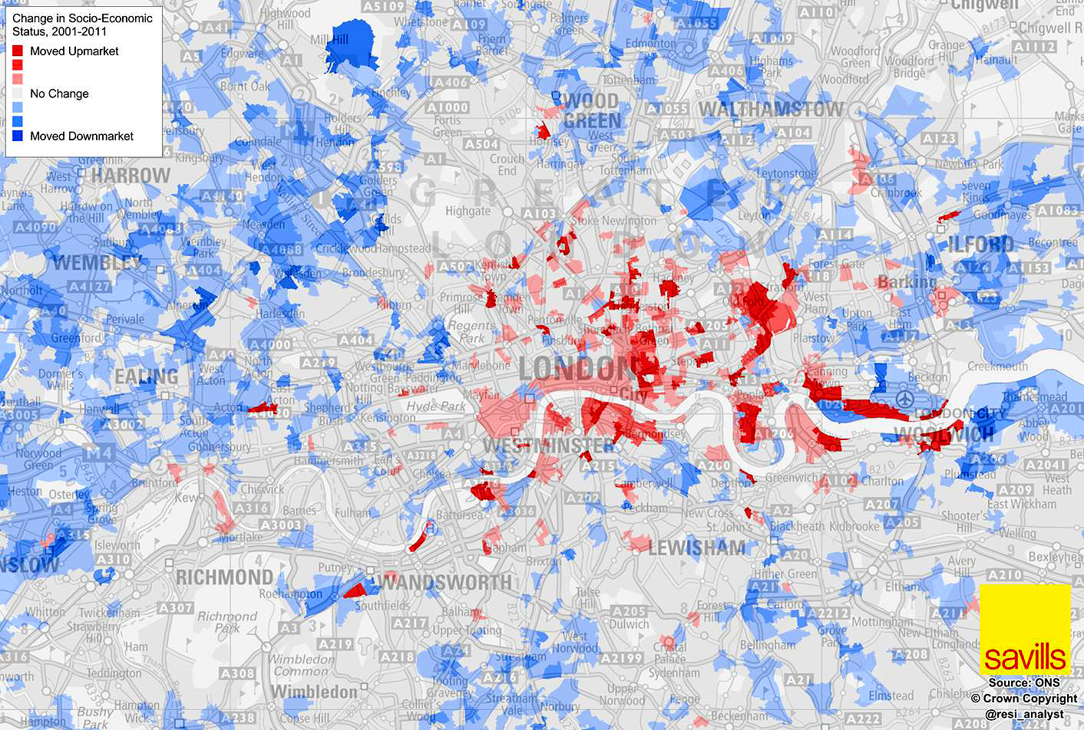

http://www.dazeddigital.com/artsandculture/article/24336/1/this-map-marks-all-of-londons-anti-gentrification-campaigns
Location of gentrification campaigns
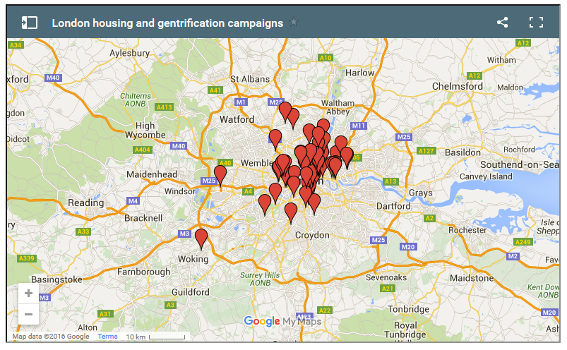

http://londonist.com/2015/10/decide-where-to-live-in-london-using-the-coffee-and-chicken-method
https://medium.com/@Sam_Floy/how-to-know-if-where-you-live-is-up-and-coming-fried-chicken-vs-coffee-shops-546080119f98#.o5qwlcpdz
- Mapping density of coffee, chicken and house prices
- 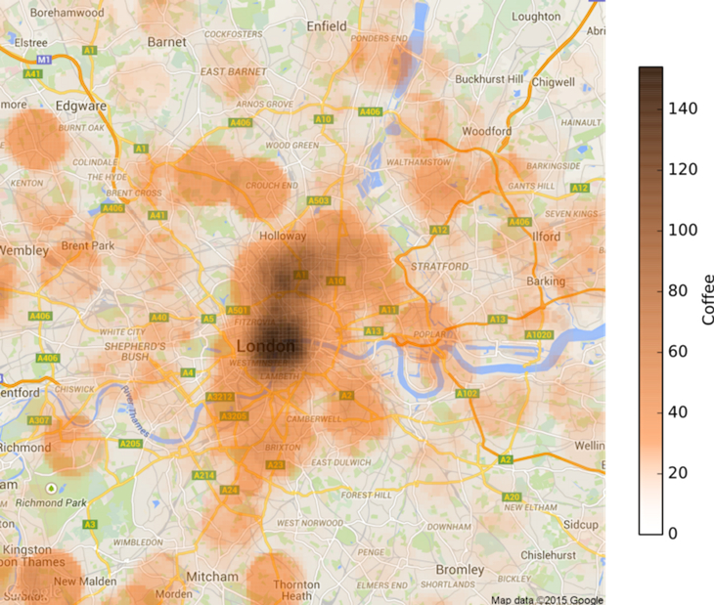

http://anthropologicalurbanism.tumblr.com/post/132076167224/mapping-gentrification-in-london-through-nightclub
Mapping gentrification through nightclub closures